Shopping

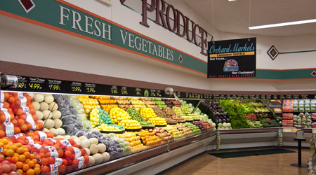
12:02 PM Sunday, October 19 North East
1. Orchard Market is located on Lloyd’s Bayou just off of M-104. This is where I typically shop for groceries because it is right up the road from my house. (Absolute Location; Movement of Goods)

Church
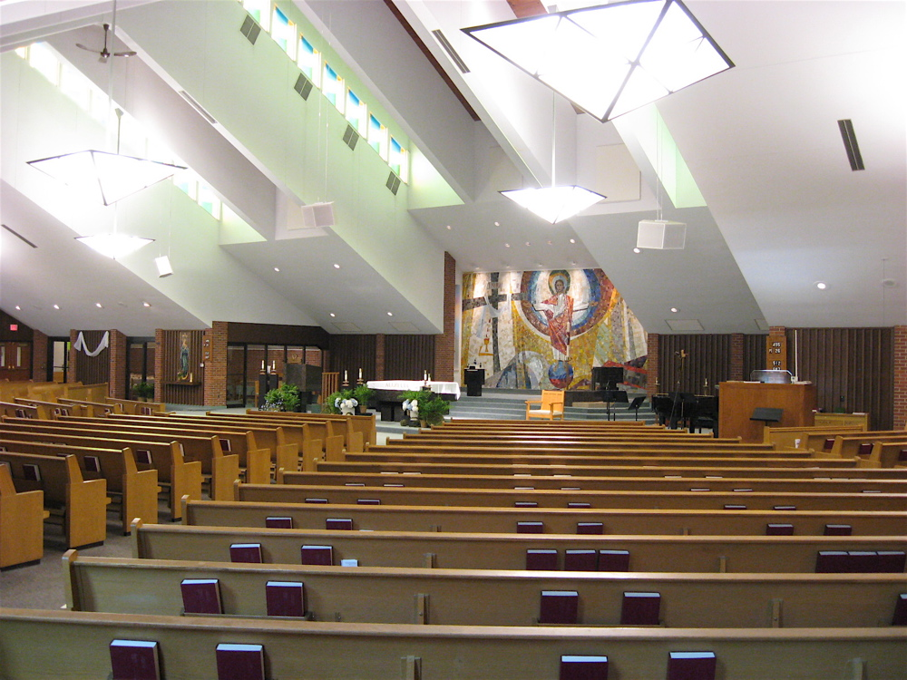
12:10 PM Sunday, October 19 West
2. St. Mary’s Catholic Church is located on E. Savidge in Spring Lake, MI. On a typical Sunday like today, the parking lots are full and traffic is backed up for several blocks. It is the church our family has been coming to for many years. (Absolute Location)
Home Base
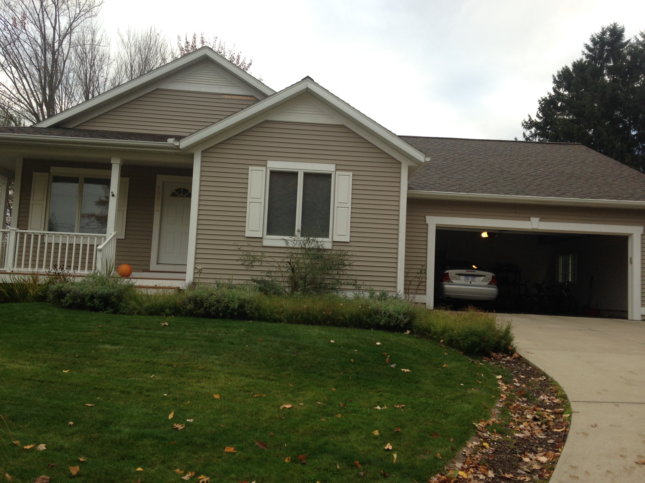
3:25 PM Sunday October 19 South East
3. This is the front of my parent’s house in Spring Lake, MI. I commute to school from here everyday. I have called this place home for most of my life. (Absolute Location)

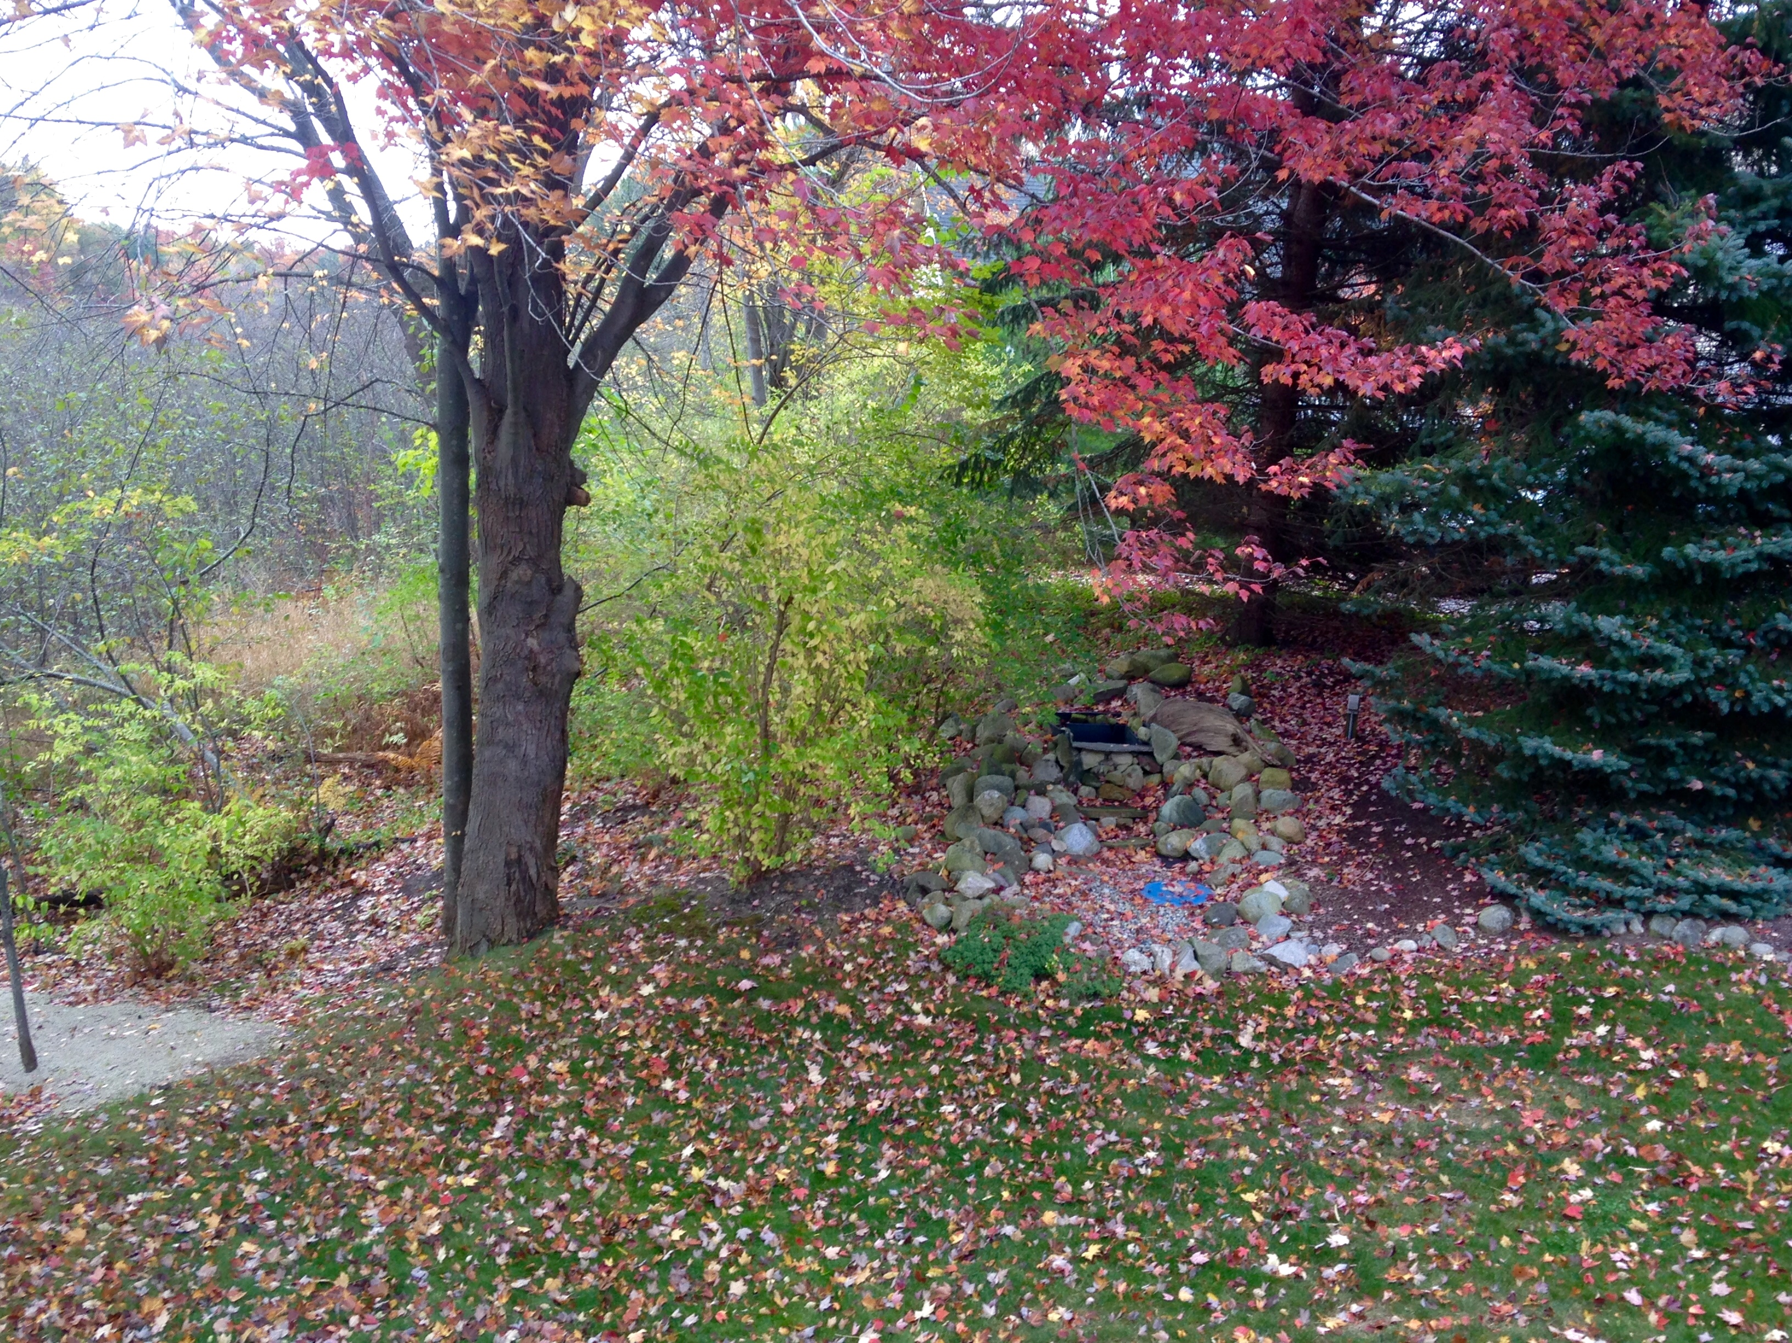
3:27 PM Sunday October 18 South East
4. This fountain is in the back of my parent’s house in Spring Lake, MI in the garden area. (Relative Location)

School
10:00 am Monday, October 20 South
5. I have spent a lot of time at GVSU for the past 3 years. I have to drive through farmlands, cornfields and many back roads to get to school everyday. I love driving under the copper entrance everyday. (Relative Location, Human-Environment Interaction)

Soccer
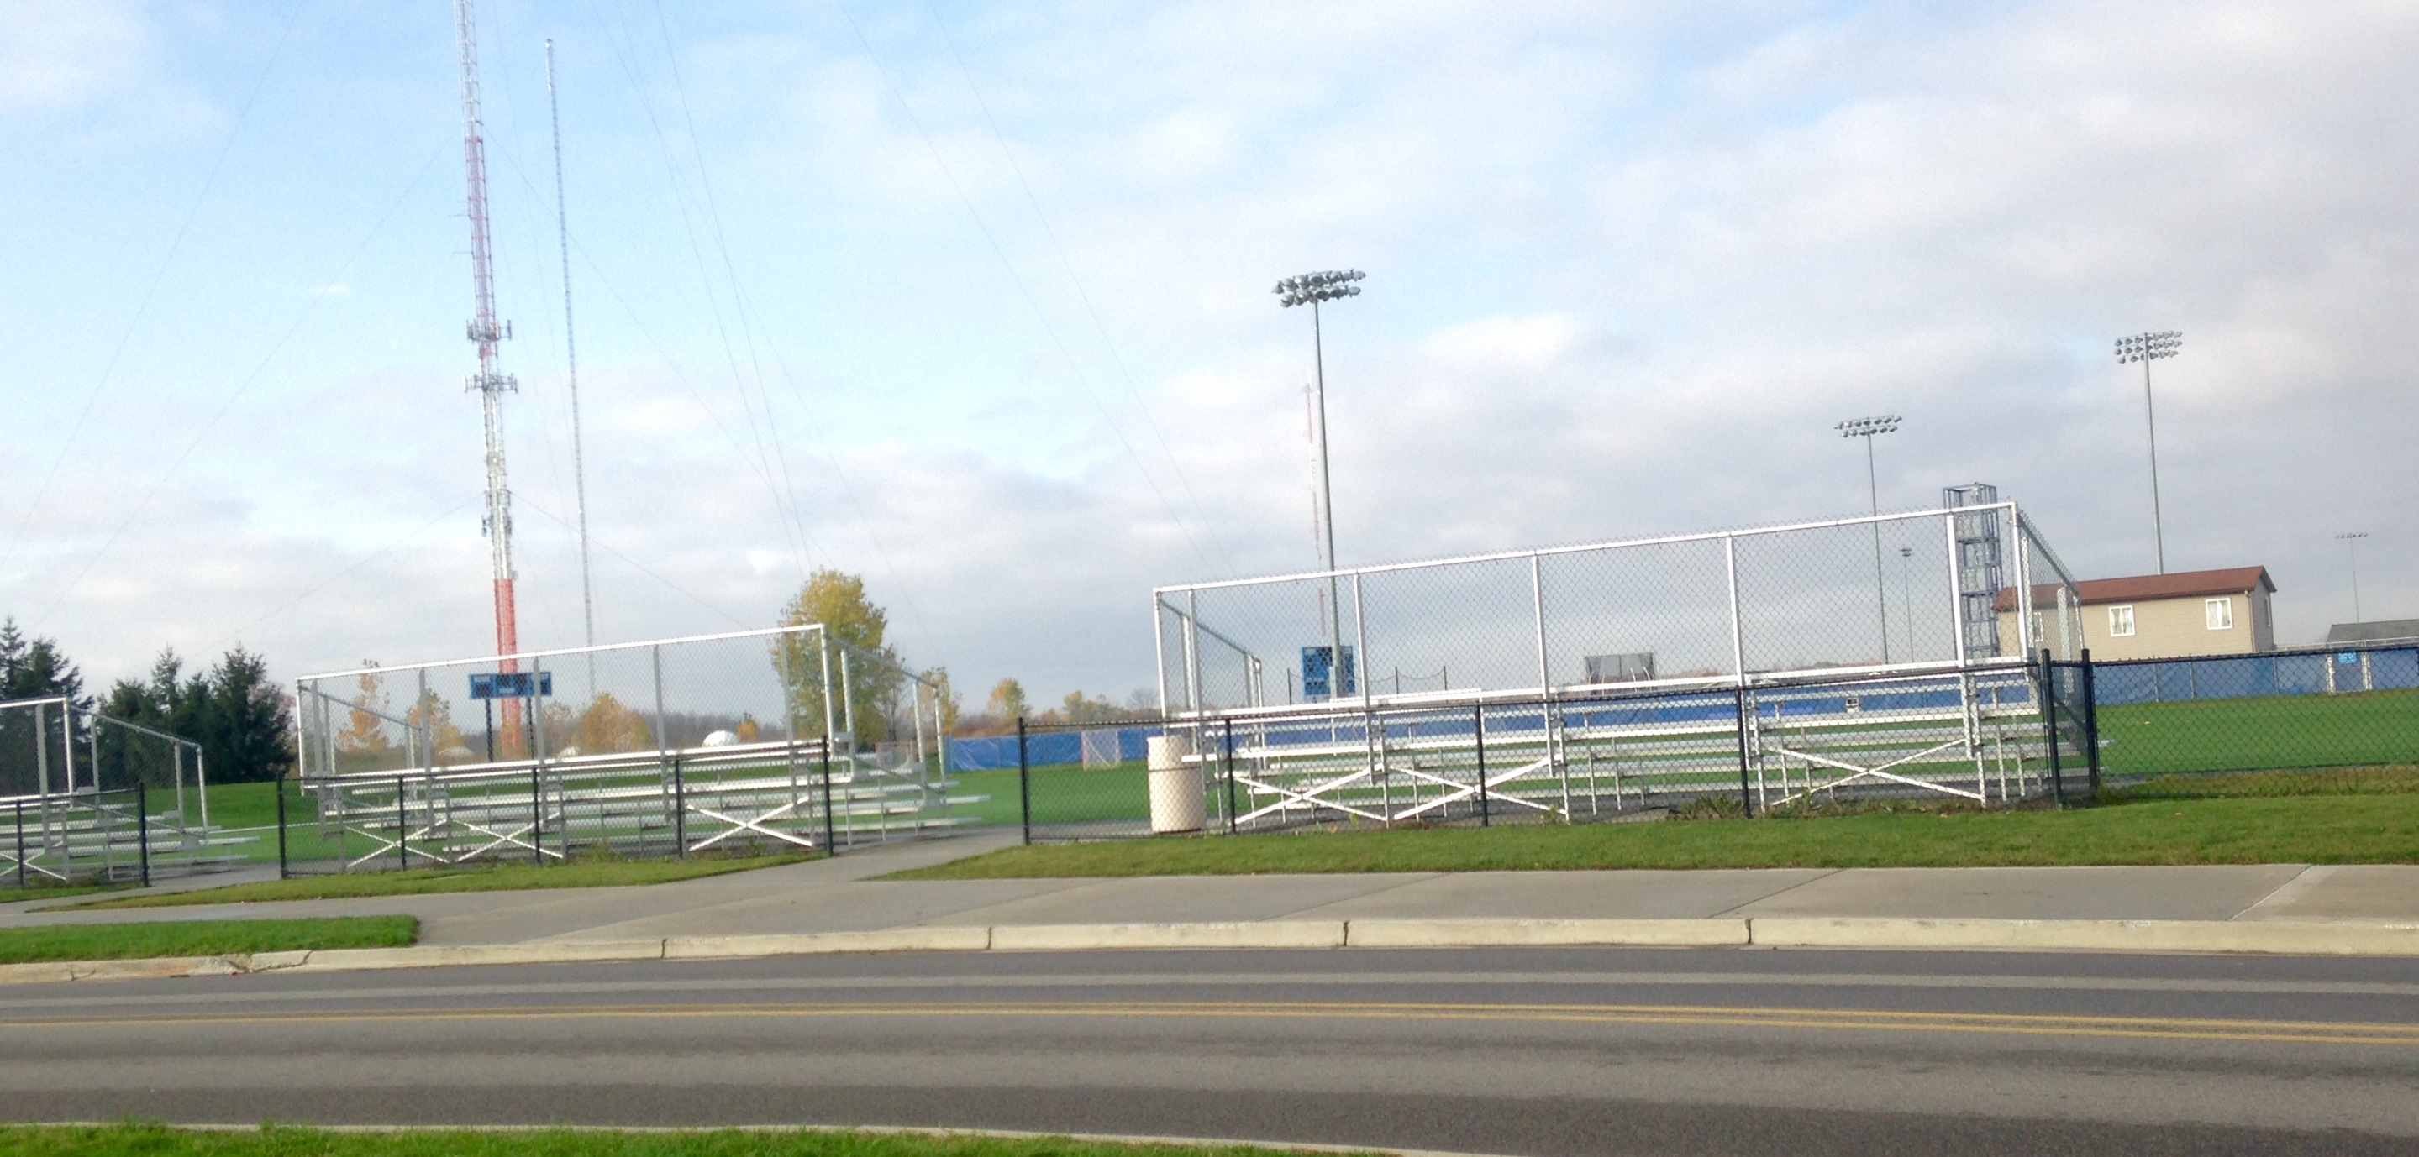
7:30 pm Sunday, October 19 West
6. One of my favorite hobbies at GVSU is playing intramural soccer. I grew up playing soccer and it’s fun to still be able to play on the nice turf fields at school. (Human-Environment Interaction, Movement of People)

My Ride
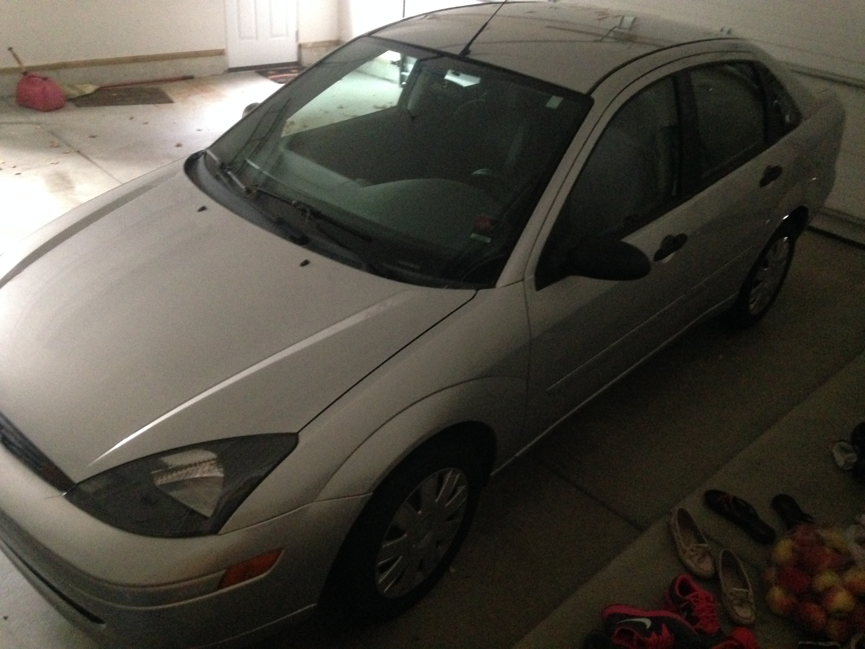
8:00 AM Saturday, October 18 North East
7. I proudly bought my own car 4 years ago and it has taken me everywhere I have needed to go. I have put many miles on it just from being a commuting student. (Movement of People)

For Fun
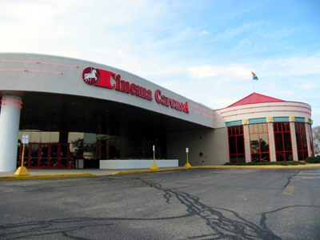
1:00 PM Saturday, October 18 West
8. The Cinema Carousel in Norton Shores, MI has been the movie theatre my friends and I have gone to for many years. (Absolute Location)

Work

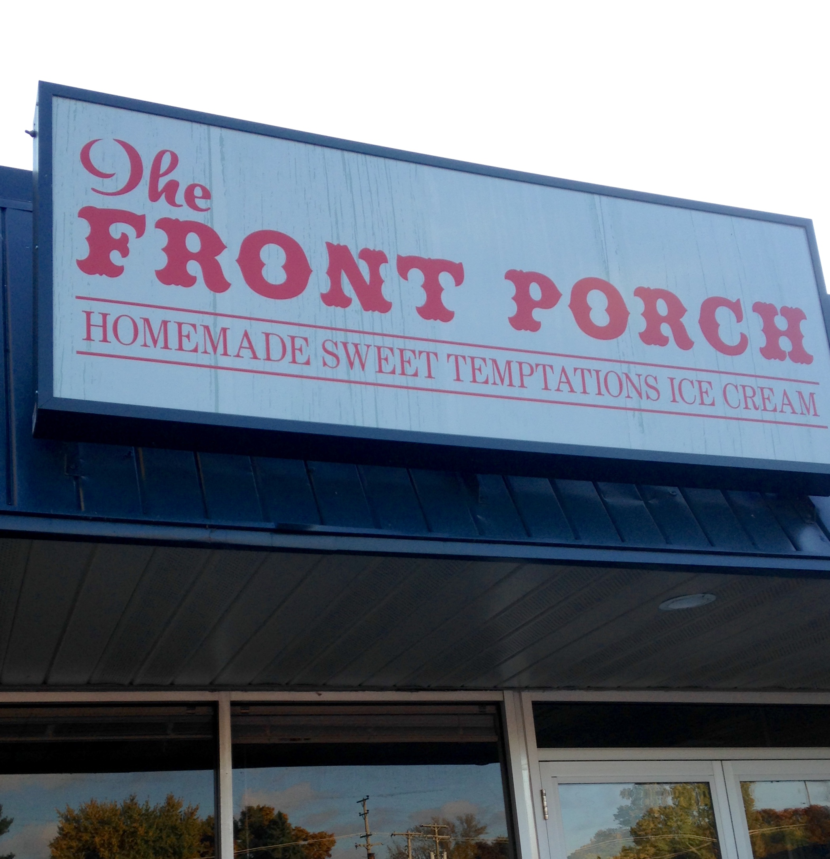

12:50 PM Saturday October 18 North West
9. The Front Porch Ice Cream Shoppe in Spring Lake, MI is a popular place for tourists in the summer. I have worked here for over 5 years so this place has become a second home for me. (Absolute Location, Movement of Goods)

Summer Spot

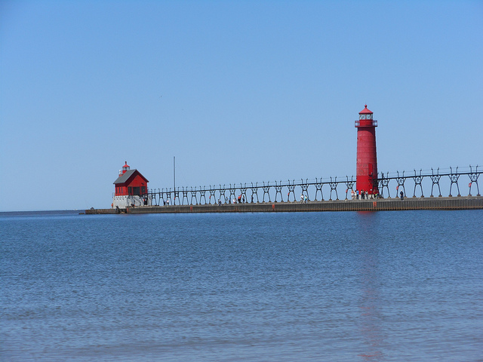
3:00 pm Sunday October 5th North West
10. Grand Haven State Park is a very popular place in West Michigan, especially in the summer. I spend a lot of time on the beach with family and friends in the summer relaxing and climbing the sand dunes. Ships travel through the channel next to the pier bringing in supplies and minerals. (Human-Environment Interaction, Region, Natural Characteristics of Place)

