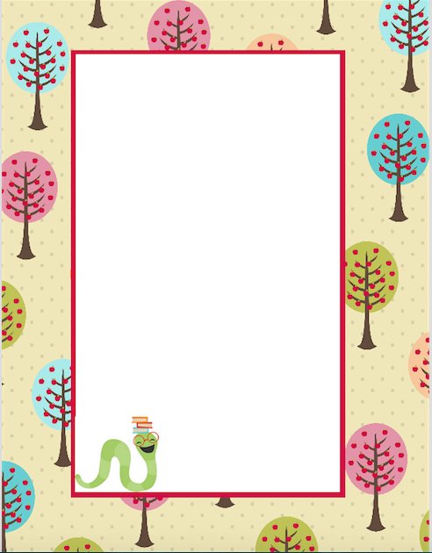

**Dear Parents,**

Welcome to sixth grade! I am so excited to have your student in class. We are already off to a great start! I would like to introduce myself and describe how our classroom will run this year. My name is Sarah Park and I am your child’s primary sixth grade teacher. I am located in Room 10 and invite you to stop by anytime, whether it be to talk about your child’s progress, volunteer or just out of curiosity. We love classroom visitors!

Curriculum:

In our classroom, your child will engage in hands on, engaging assignments that will allow your students to grow as learners. Your student will be instructed using a flipped classroom model. This allows the students to listen to instruction at their own pace at home, while allowing them to engage in productive struggle and to ask questions while in class. This model allows students to become more independent learners and promotes collaboration and team building by working through problems as a group.

Our district follows the State mandated Common Core State Standards as a basis for our curriculum. As a district, we have also implemented Discovery Education as our primary curriculum resource. We will be using technology as a tool for instruction. Your child will be provided with his/her own IPad for the year and will have access to the use of Chrome Books. Since technology is such an important tool, your child will be supported using a special technology literacy curriculum.



Philosophy:

Every student is a unique individual who needs a caring and engaging atmosphere in which to grow, learn and mature emotionally, intellectually, physically, and socially. It is my goal as an educator to help students meet their full potential in these areas by providing an environment that is safe, supports risk-taking and progressive struggle and invites all ideas to be shared.

Our technologically infused classroom is one that allows students to take risks and to grow as responsible individuals. Students deserve to have and make choices and will be held accountable for their learning and actions.

As the teacher, my goal is to:

-Encourage students to take control of their own learning.

- Help students to realize the consequences of their own behavior.

- Allow students to discover solutions to their own problems.

- Help students to understand their needs and identify legitimate ways of satisfying those needs.

- Improve relationships in the classroom through the choices we make.

Expectations:

Our classroom community expectations revolve around a sense of respect for each other, our school and property around us. I expect students to make the best choices in order to help themselves grow as learners and to help those around them. This includes coming to school ready to learn, with all assignments complete. Students will have class jobs that they will be expected to complete each week in order to have a sense of responsibility and contribution to the class.