My practice best represents that of a Choice Theory classroom. Choice Theory attempts to explain that people choose their behavior and that this choice is based on their needs. Students have basic needs such as survival, belonging, power, freedom and learning. Behavior is learned and gives these needs purpose. Choice theory contends that we are internally motivated. I want my classroom to run on internal motivation, instead of externally through prizes and rewards. Rather than being shaped by rewards and punishment, I want students to make choices and have control of their lives. By sixth grade, students should especially be able to do this. Some of these skills need to be coached and taught, especially if they haven’t been in the past. Students have limited knowledge of behavior options available to them, which mean teachers need to help them make better choices and provide those options.
Choice Theory emphasizes the importance of building and maintaining positive relationships with others to create a shared vision. Students who do this become more motivated to pursue common goals and are more apt to work collaboratively. This collaboration element is one of my highest expectations for my students. My classroom will revolve around individual, group and class goals that will carry through the day, week and year in order to create unity and purpose in our classroom. Overall, I have an expectation that my classroom will be fun, engaging, interesting, challenging and comfortable for all.
By building relationships and collaboration in the classroom, we are also building trust and a positive classroom culture. Before even beginning the year, it is important to understand where all of my students come from. Even in a minimally diverse school setting such as Jenison Public, all of my students will be diverse in the way they learn and think and every student’s culture needs to be fairly represented and respected in the classroom. It is important to recognize who students are individually, not just as learners, but as humans first. It is my job as the teacher to be culturally aware and tolerant in order to create a safe environment that is equal for everyone.
Example Discipline Scenario:
A student calls out and interrupts a lot in class and is difficult to motivate. As a choice theorist, I would allow the student to excuse himself or herself and come back when he/she is ready. When they come back, I would thank them for making the choice to come back and allow them to tell me what is going on in class. Based on the students response some options to reply with may be
“It sounds like you want more attention from me.”
“What are you doing in class to get my attention?”
This is in the hopes of the student identifying that he/she is interrupting in class.
I could continue with
“You have my attention now, she this what you wanted?”
“How’s your behavior in class working for you?”
The student needs to be able to come up with a plan. I will follow up to make sure the issue is then resolved. For example, if they then choose to move away from friends. To follow up even more if the problem continues, the questions need to go back to the student to recognize what they wanted, and how they may best achieve that.

For other minor behavior problems around the class, this line of questioning may help,
“You’ve got a lot of choices available to you, what are you choosing to do right now? How’s that working for you? Is there a better choice you can make?
This places responsibility back on the student to find a solution. It also identifies that the student has made the choice for their behavior. It is extremely important to teach students to define the problem and to find solutions to it.
If disciplinary concerns are happening as a whole class rather than just an individual, the class will brainstorm solutions to the problem as a whole. For example, if everyone is being loud. The students may come up with solutions such as changing seats or doing the task individually for a while.
It is important to recognize that students misbehave because they are either attention seeking, power seeking, revenge seeking or because of failure avoidance. Understanding these reasons for misbehaving and allowing students the choice of action afterward, avoids the resentment, rebellion, revenge, and retreat of punishment given by me. Giving students the choice makes them better problem solvers.
Instead of acting as the disciplinarian or as the controller of the room, Choice Theory leads me to the strategy of being the classroom Manager. This strategy allows me to create a learning environment that is inspirational and allows students to critical think. This is because I will be student-focused and will be able to focus on content, rather than behavior. My role as the classroom manager is to help my students to see that the working hard and doing what I ask is worth the effort. This is achieved by developing positive relationships with my students and providing active, relevant learning experiences where students can demonstrate success. I will implement this by having weekly check-in meetings with my students and allowing students to take turns eating lunch with me so I can get to know them even better and creating engaging lessons that foster to their needs and are engaging and relevant to their lives.
When creating lessons, I want to make sure all of my students needs are met. Learning increases when they are engaged, there are minimal disruptions, and they feel connected to the material. To make this explicit, I will have all of my students write “I can” statements for the lessons and will reflect on their learning afterwards.
My 3 major focuses are:
- Minimal Coercion
Rather than trying to “make” students behave, I will build positive relationships with my students, managing them without coercion because it doesn’t inspire quality. Trust needs to be built, which it will by building those relationships.
- Focus on quality
I have high expectations for my students. I will implement standards-based grading where students are expected to master concepts before moving on. I will give students the choice to re-take and make up work until they hit the goals and objectives. I want to emphasis deep learning and the application of the concepts, rather than focusing on grades.
- Self-evaluation
Given helpful information such as rubrics and models, students take on greater ownership of their learning by evaluating their own performance. Encouraging students to reflect and self-evaluate promotes responsibility and helps students to pursue goals and become skilled decision-makers because they are becoming more involved in their education.
Curriculum is more than the standards that are expected to be taught. I intend to teach my students life skills that will allow them to become productive members of our democratic society. I want to create a classroom that is all-inclusive and teaches students to never isolate others, which leads to a healthy classroom climate and culture. To address this hidden curriculum, I will address a life skill every week that is relevant to their lives. Also any issue such as bullying or unhealthy competition will be seen as a learning opportunity where students will have choice with appropriate punishment. Visual of my philosophy of curriculum:
D.I. + V.C.
Visual Cues
Direction Instruction
Memorizing, independent work
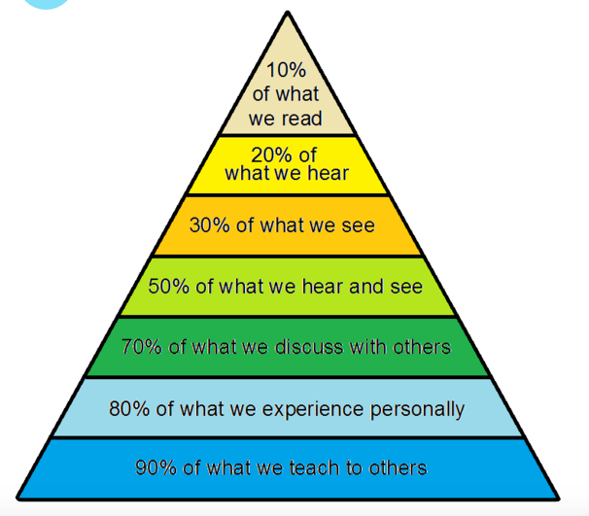
Collaboration + Evaluation
Project/place based
Life experience
Collaboration/ Groups

